**Citi Bike Analytics – Write Up**

The Citi Bike Analytics covers trip history from June 2019 to June 2020. The data set has a total of 411,876 trips during that time frame.

**Tableau Link:** <https://public.tableau.com/profile/swati.swain#!/vizhome/CitiBikeAnalytics_15965254446560/BikeDataAnalysisStory>

**Trip Duration Trends:**

There were more trips in June however people took longer trips in May. Since May and June are summer months, this could trigger more or longer trips in these months. Also, till fall (September), a good number of bikes were rented. Thus, making May – September more profitable months for Citi Bike.

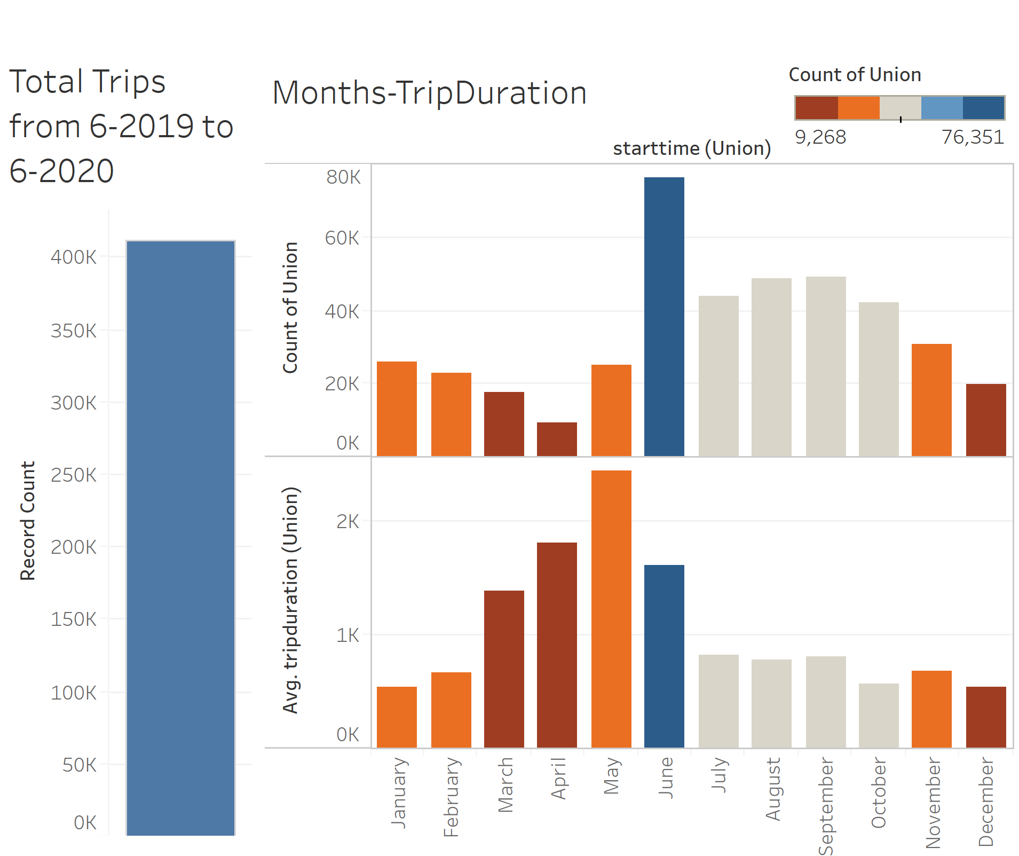

**Peak Hours:**

The 1st peak hour during a day would usually be 7-8 AM regardless of the season and there is continuous bike usage throughout the day until 11 PM.

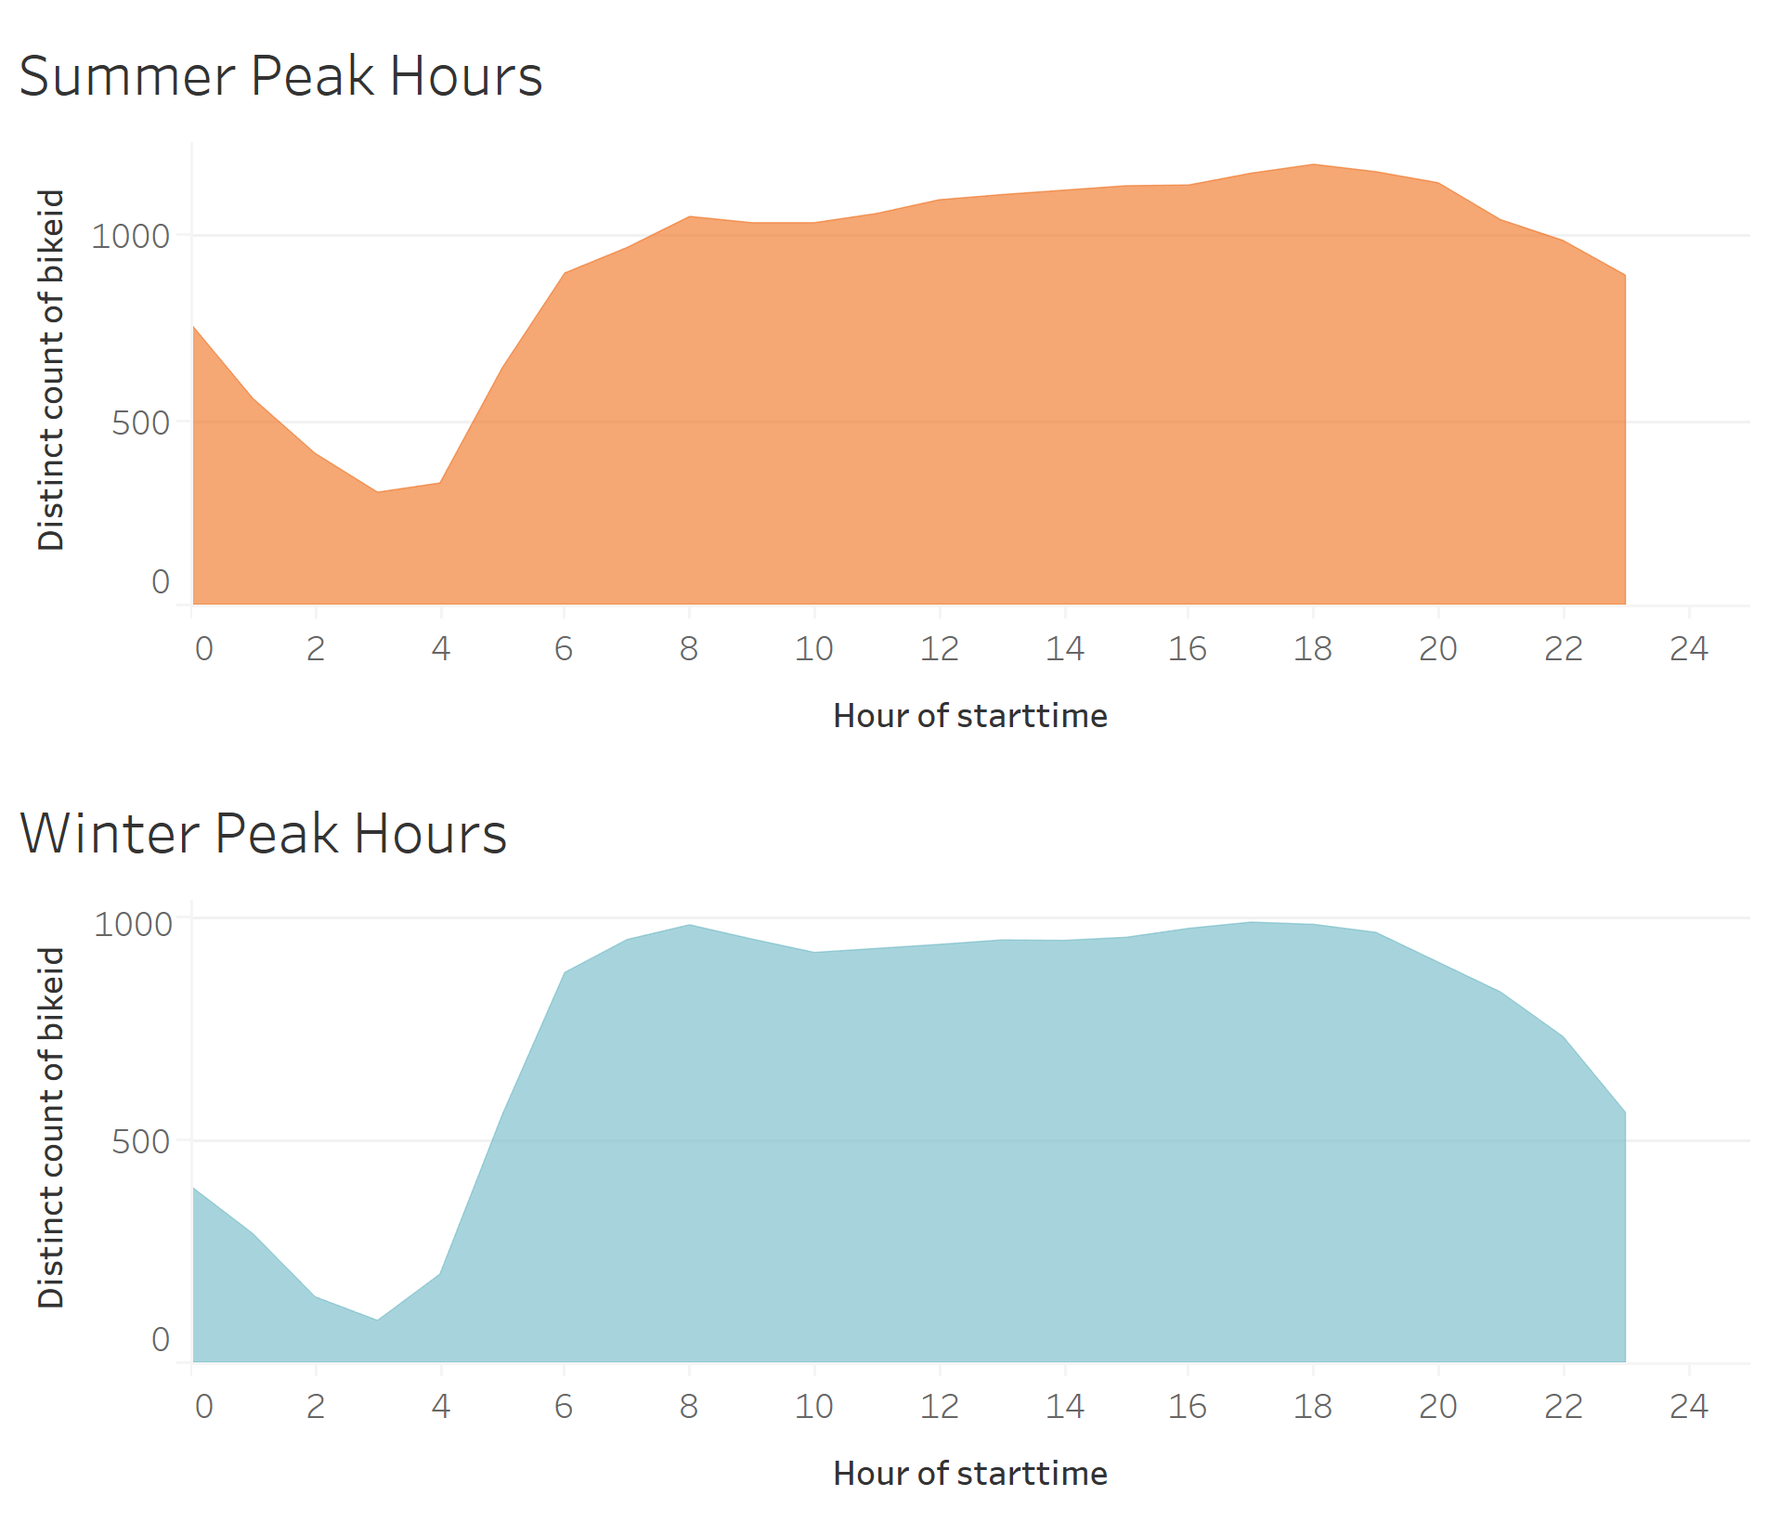

**Age Distribution:**

Average trip duration is highest for ages around 80 while ages around 50 take longer trips. It possible retirees use biking as a casual activity thus taking longer trips.

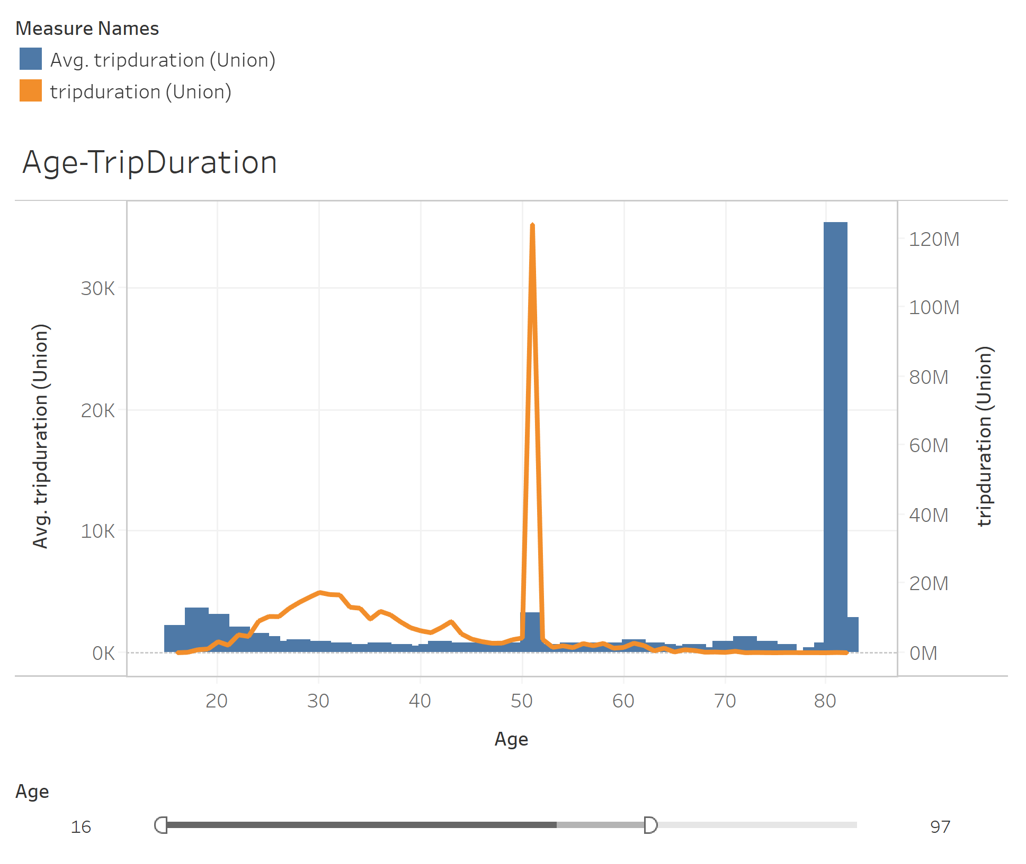

**Gender Analysis:**

In total out of 411,876 trips, Female % = 24.2% and Male % = 66.5%. Thus, in general, male ridership is roughly 3 times more than female ridership.

It is interesting to note that female ridership increased from 23.6 % during weekdays to 25.6% during weekends.

Limitation:

6.9% of the riders didn’t provide gender information and most of them (15.4%) are weekend users so we will not be able to tell if female are more willing to ride on the weekend than they do on weekdays, but we may still determine that male riders are the dominant customer base at all time

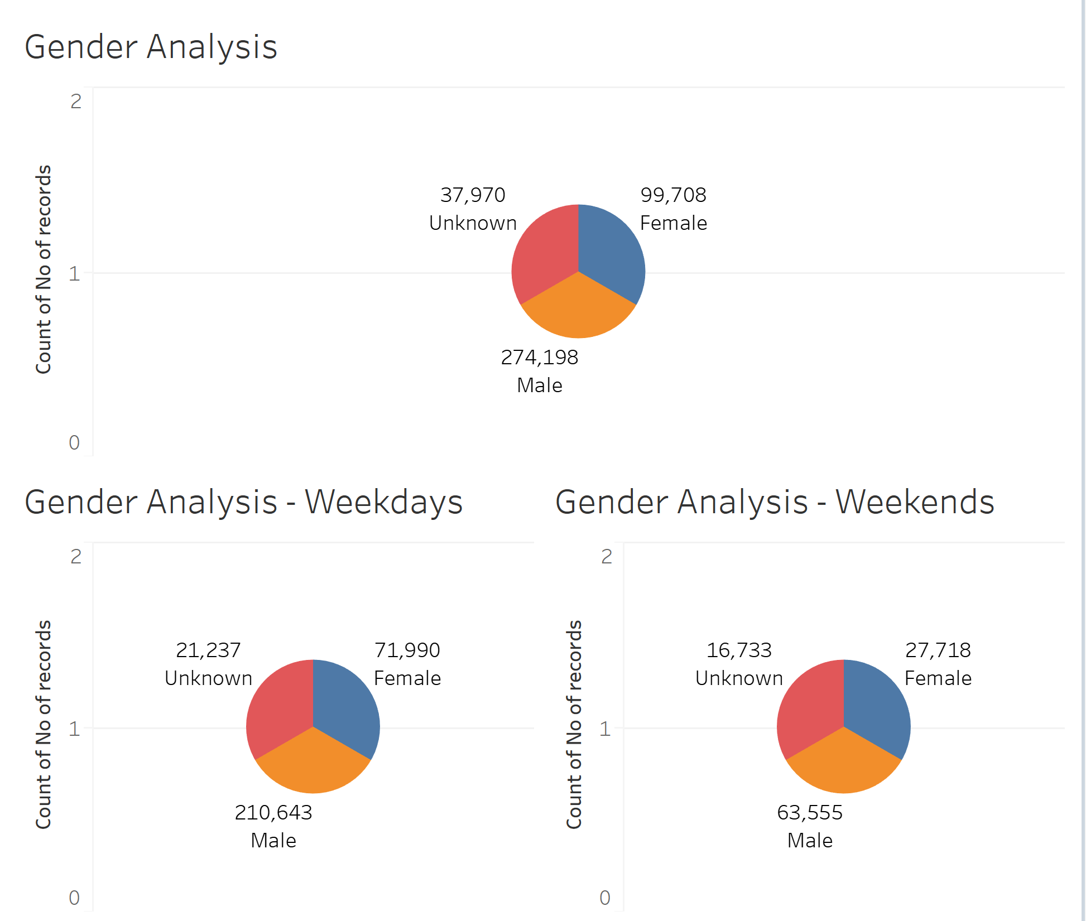

**Female Ridership Growth:**

Female ridership is more in summer and summer weekends seem to have more % increase in female ridership.

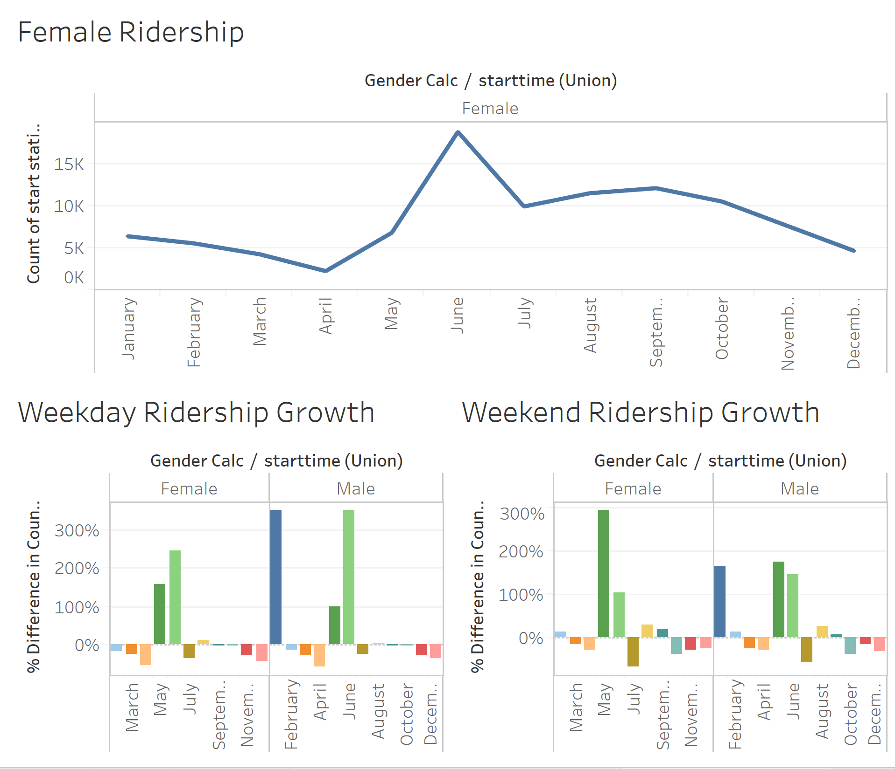

**Station Popularity with time:**

Q3 quarter fairs better than other quarters in popular start and end stations. It ties back to the fact that more bikes are used during summer and fall. Q1 is the most affected in all the top start and end stations owing to the cold New York winters.

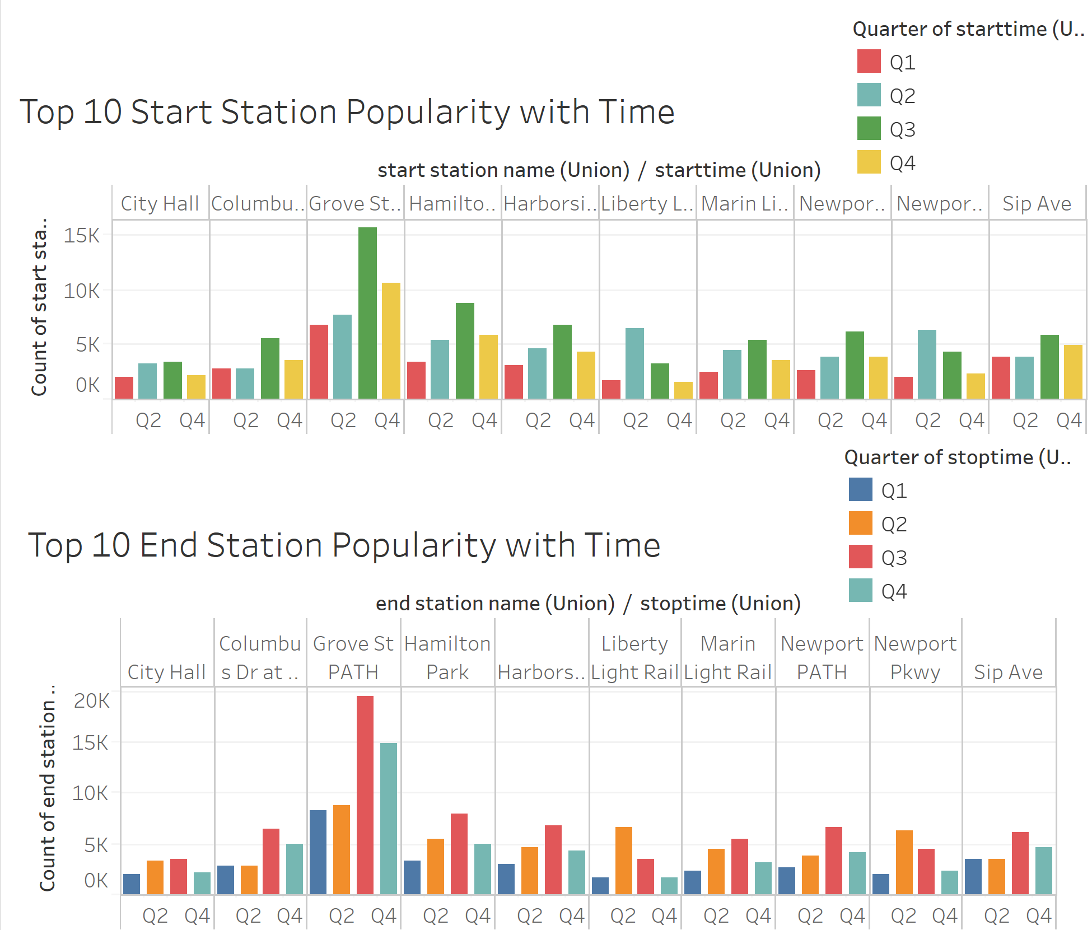

**Top 10 Stations – Start & End:**

Grove St Path is the top station both for start and end of a journey followed by Hamilton Park.

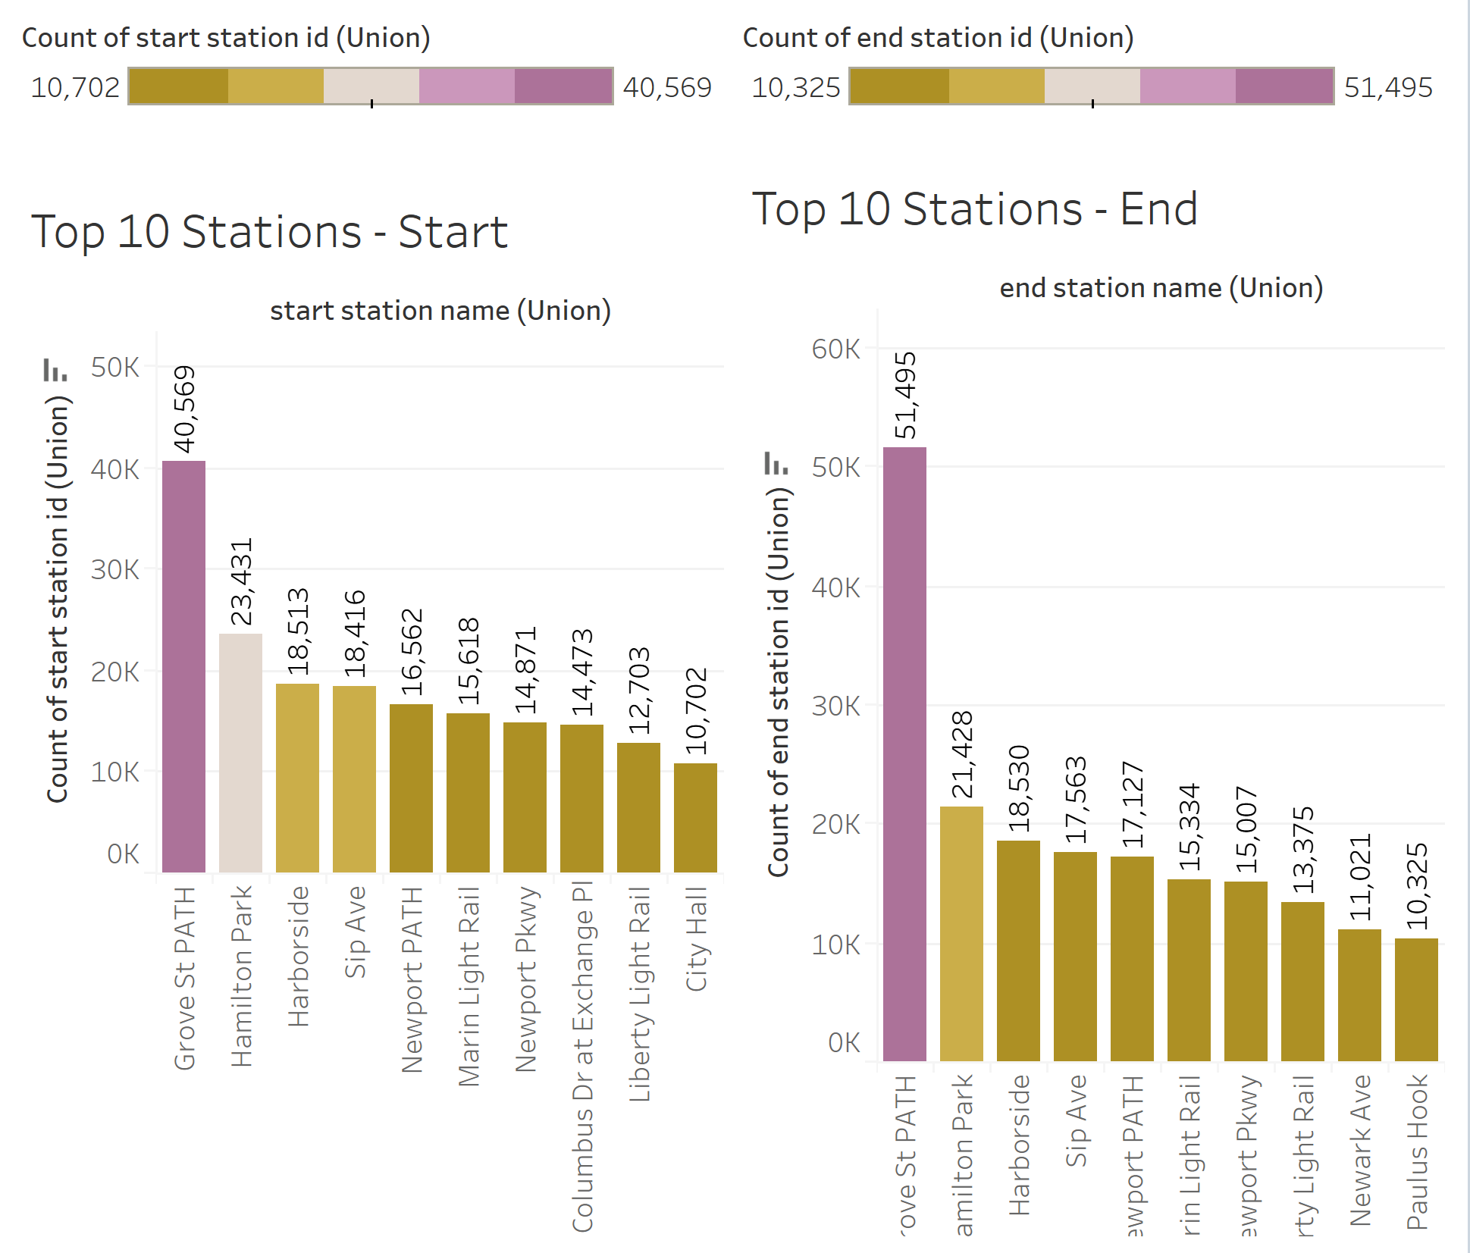

**Bottom 10 Stations – Start and End:**

Removed outliers from the data (stations with less than 20 trips). Jackson Square and Union Street have the lowest trips if we look at start at and end trips together.

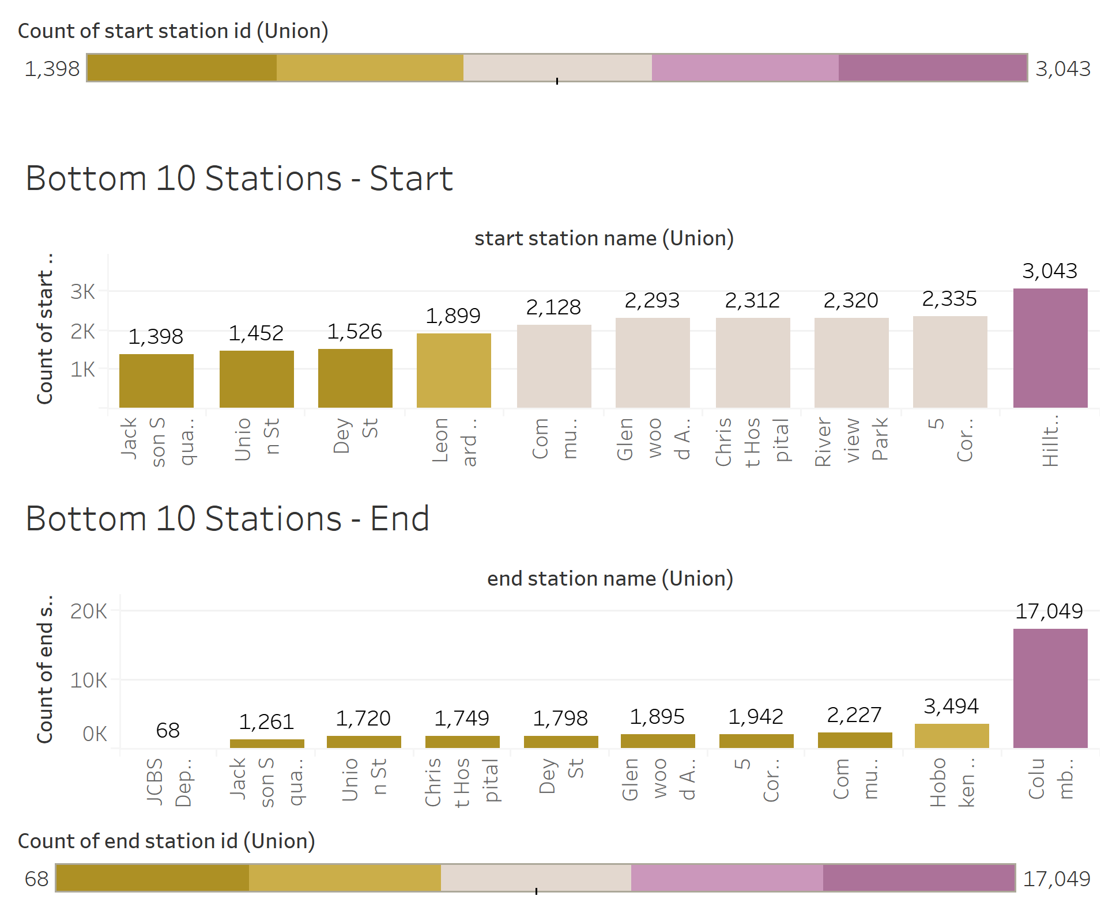

**Map Visualization for City Officials:**

A lot of start and end stations are concentrated around Jersey City. It is possible a lot of people work in Jersey City and could use bikes to transit from metros to office. It is interesting to note that there are a lot of end stations in Manhattan (although smaller in counts), indicating that quite a few riders might be living in Manhattan.

